North West London Integrated Care System update

December 2021

This is the November/December update from the NW London Integrated Care System (ICS) and includes:

- Covid-19 vaccination programme
- Inequalities framework
- Our financial challenge
- Acute care update
- Mount Vernon cancer services
- Mental health
- Senior appointments

- COVID-19 vaccination programme

At the time of writing, NW London has administered 3.5million doses of covid vaccine.
That is roughly 1.6million 1st doses, 1.4million 2nd doses and nearly half a million boosters.

Following updated guidance from the JCVI, the NHS will shortly set out how staff will expand the booster programme – this will include how booster jabs will be given in priority order so that the most vulnerable people are protected first, while also increasing capacity to vaccinate millions more people in a shorter space of time.

In early November the national average for booster uptake was 54%, London was the top region at 57% and NW London was the most successful at 62.9%. Boosters are now available for anyone over 40, six months after their second dose. We are preparing should the booster be offered to more adults.

The table below shows vaccination by cohort from care home residents where we have around 96% vaccinated to 12-15 year olds where 65% remain unvaccinated.

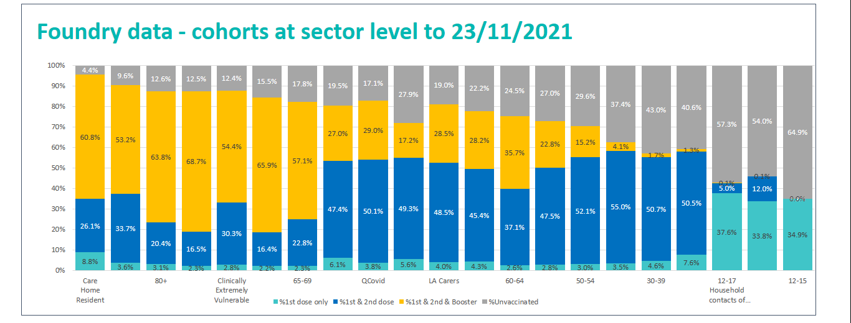

The 12 to 15 year old vaccination team have vaccinated over 36,000 children in an 8 week period. All schools have now had at least one visit. Phase 2 of the schools’ vaccination programme is working on:

- 1. Mop-up visits: for schools that have outstanding consents for those children still requiring vaccinations.
- 2. Schools under 20% uptake: A big focus on schools that have under 20% uptake particularly those larger schools with 600+ pupils & over 30 schools identified in this list.

We continue to vaccinate first, second and booster doses through all sites which includes 83 pharmacies, 26 community sites and a large vaccination site. For the weekend of 26 – 28 November there will be an additional 20 pop-up events taking place (with more likely to be confirmed), including community sites, vaccine bus and existing PCN locations to drive forward the vaccine uptake.

Planning has begun for a One Year on campaign, in recognition of the first vaccination given on 8th December. The campaign will highlight the positive stories about the people who have played key roles in the vaccination programme. This will include community champions, NHS workers, volunteers and faith leaders. More details about the communications around this campaign will be available in the coming weeks.

The focus for communications and engagement in the run up to Christmas is to continue promoting first vaccines to people, where there are still large numbers yet to be vaccinated and to encourage people to come forward to get their boosters. Coronavirus vaccinations forms part of the winter communications plan.

- Inequalities framework launch
The North West London ICS inequalities framework, which is a significant milestone in our ambition to tackle inequality across North West London, will be published in January. The framework document has been jointly produced between the NHS and local authorities in North West London and is intended to start a big conversation with our residents about how we eradicate health inequalities.

In developing the plan, we have recognised key learnings we have identified during the Covid pandemic, and acknowledged that if we want to tackle inequalities we need to work differently, recognising opportunities in utero, in childhood, and in adulthood. Our plan acknowledges the need to address historic racism through ongoing hyper-local engagement with independent facilitation.
We will expect all ICS workstreams to specifically work towards:

- Reducing inequality of access
- Reducing inequality of outcomes
- Reducing inequality of experience
- Enhancing economic impact of our work
The plan sets out pledges and principles that will enable us to do that – but the next step is to hear from the public, especially those communities we have not always heard from and where we may need to rebuild trust.
In the weeks ahead, we will be organising events in each of our boroughs, encouraging the public to have their say on their challenges, how we might work with our communities and residents differently and how we can work together to move this agenda forward.
This is not a programme: it is a whole new way of working with our residents and is a key priority of the North West London ICS.

- Our financial challenge

NW London finished the first half of the financial year (H1) on plan and submitted the operating plan for H2 in November. The headline performance metrics in the plan met or exceeded the national targets but did not quite achieve the NW London ambition of 100% on elective services. We are looking at additional initiatives e.g. increased usage of the independent sector and insourcing to improve the performance further.

Workforce is the largest constraining factor in planning and it reduced activity. Trusts are reporting that there is a reduction in staff available for bank work, creating greater agency pressures or gaps within services. The recruitment challenges are in acute services, primary care, community services and mental health. HR directors are looking at sector-level international recruitment and we will need to take further actions around recruitment, retention and lowering sickness and absence rates where possible.

The ICS will live within its envelope in H2 and is planning a surplus of £30m. Funding will cover the planned activity levels as well as funding the challenged Trusts (The Hillingdon Hospitals Trust - £16.5m and LAS - £14m) as these organisations cannot deliver within the initial funding allocation. Other areas being supported include winter funding (£12m), support for LA discharge schemes (£3m), increased critical care beds (£16m), supporting balance sheet challenges (£11m), revenue to capital recharges (£8m) and we are working on further invest to save and activity increasing schemes.

Despite having a favourable position in year the ICS remains challenged in its underlying deficit position i.e. the excess of recurrent cost against likely recurrent income excluding the non-recurrent pandemic support, so the focus for the Financial Recovery Board is on improving the run rate of recurrent expenditure as we leave this financial year. To achieve this we need to improve the level of recurrent Cost Improvement Plans (CIPs) in 2021/22 as Trusts are reporting an increased reliance on non-recurrent measures in year. Failure to do so will increase the CIP levels required in 2022/23. Overall the underlying deficit has reduced to £325m with improvements seen being an increase in recurrent system funding, an reduction in the underlying deficit in LAS whilst the Hillingdon position has worsened.

Month 7 results showed the system broadly delivering to plan.

- Acute care update (Chelsea and Westminster Hospital, The Hillingdon Hospitals, Imperial College Healthcare and London North West University Healthcare)

In early 2021, the four acute provider trusts came together to establish a joint acute care board and programme for North West London to guide and coordinate developments across all of our key operational areas, including: planned surgery, cancer care, outpatients, intensive care, urgent and emergency care and diagnostics and imaging. The effectiveness of our response to the pandemic has demonstrated that we can – and should - do more to harness our collective resources, join-up our care and reduce unwarranted variations in access and outcomes.

Our immediate focus is on recovery from the peak of the pandemic, reducing our waiting times for planned care while continuing to prioritise by clinical need and minimising the ongoing risk of Covid-19 infection. We also want to build on new ways of working catalysed by the pandemic, drawing on evidenced best-practice and deeper collaboration, to make longer term, sustainable improvements in quality, fairness and efficiency.

Increased planned care capacity and reducing long waits

In October 2021, we averaged 92 per cent of pre pandemic planned care levels, up from 83 per cent in August 2021. Within that, our combined outpatient capacity for October 2021 was up to 101 per cent of pre pandemic activity. This is currently the highest level of planned care recovery across London. Referrals are also continuing to increase, resulting in a four per cent increase in our overall waiting list 10,000 patients since September 2021.

Graph Y – Current Elective and Outpatient activity versus pre-pandemic levels

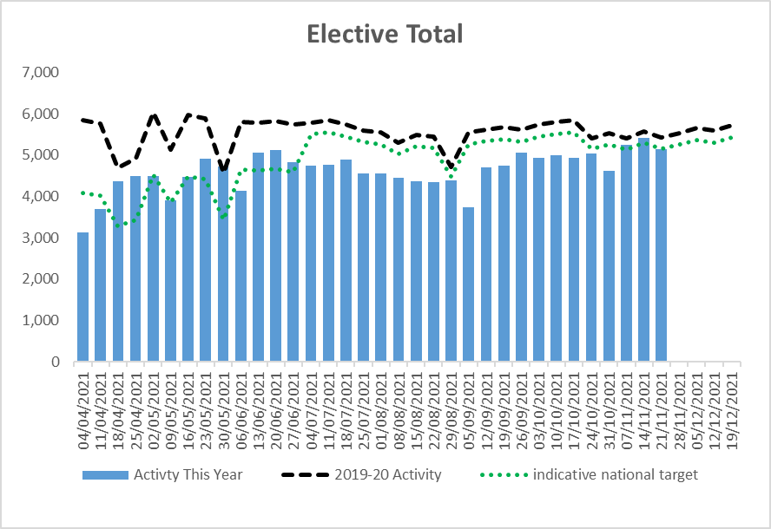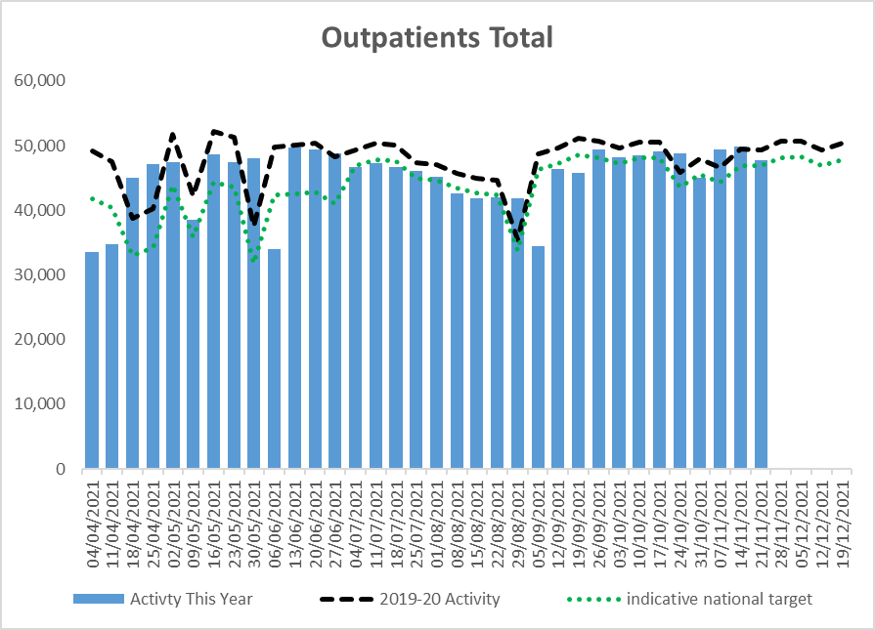

We remain on track to meet our target to have no patients waiting over 104 weeks by March 2022. We currently have 80 patients who have been waiting for 104 weeks, down from a peak of 126 patients in July 2021. We are finding it more challenging to reduce the number of patients waiting over 52 weeks and have remained at around 4,000 people through October, though down significantly from the peak of 6,802 patients in February 2021.

Graph X – Patients waiting over 104 weeks and reduction trajectory for the remainder of 2021/22

Given our ambitious target for the second half of this year, to stabilise the size of our waiting list, we need to continue to increase our planned care capacity to above 100 per cent of our pre pandemic activity throughout the winter.

To help us boost capacity, we are maximising the use of our existing facilities, using national benchmarks and best practice (supported by the national Getting It Right First Time (GIRFT) programme) to help us understand where we should focus our improvements. Our clinical and operational leaders meet regularly through joint ‘speciality huddles’ and sector wide clinical reference groups to review data visualisations to aid analysis and agree actions.

The GIRFT approach also underpins the further development of our fast track surgical hubs -surgical facilities across our hospitals dedicated to one or more types of routine operation where evidence has demonstrated improved quality and efficiency if a surgical team undertakes high numbers of that procedure systematically. The hubs focus on six clinical specialties characterised by ‘high volume, low complexity’ procedures. In addition to the development of planned care hubs, we are continuing to support services and hospitals with particularly long waiting times by offering care at hospitals with shorter waiting times, bringing in additional capacity from third party organisations or using the independent sector.

Diagnostics and imaging

We are making good progress on recovering diagnostics and imaging capacity to pre-pandemic levels and, for all but one imaging modality, significantly exceeding pre-pandemic levels.

Modality | Percentage of patients who have been waiting less than six weeks | Activity as a percentage of activity for the same point in 2019/20
MRI | 88 | 113
CT | 98 | 135
Ultrasound | 97 | 80
Endoscopy | 77 | 114
Echo | 86 | 144

Two new MRI centres have been established at Ealing and West Middlesex hospitals, with five new MRI scanners in total providing significant additional capacity. This follows the replacement of two MRI scanners at St Mary’s Hospital earlier this year, with a further four MRI scanners set to be replaced at London North West University Healthcare by April 2022. A wider transformation programme is in development supported by national funding of £2.3bn allocated for diagnostic services in the recent Comprehensive Spending Review. National guidance has confirmed that this funding will be allocated towards three initiatives: community diagnostic centres; digital diagnostics; and replacement of aged imaging and endoscopy equipment.

Community diagnostic centres are a national initiative to build diagnostic capacity for planned care, based in the community and separated from urgent and emergency pathways. These ‘one stop shops’ for checks, scans and tests will be more convenient for patients and help to improve outcomes for patients with cancer and other serious conditions. We are looking to have new community diagnostic centres situated in at least two areas of north west London where there are significant clusters of deprivation – including one in the area of Hanwell, Southall and Greenford; and another in the area of Neasden, Stonebridge, Harlesden, North Hammersmith and Fulham, North Kensington, Queen’s Park and Church Street in North Westminster. We will be engaging on these plans over the coming months as we look to develop community diagnostic centres from next year through to 2025.

Urgent and emergency care

Attendances to our A&E services, including urgent treatment centres, in October were six per cent higher than for the same period in 2019/20. Together with continuing Covid-19 infections and infection prevention and control measures, this is creating very significant pressure on our services as we head into winter.
On top of Trusts’ own investment in urgent and emergency care services in response to increasing demand, additional funds have been allocated across the sector to support further improvements. These initiatives support work ‘to keep care flowing’, maximising our ability to care for as many patients as possible, as quickly as possible. They include extra staff and support for emergency departments and for discharge from hospital, expanding ‘same day emergency care’ services and additional community beds.
We have also this week launched an ‘inner’ north west London health inclusion service – based at St Mary’s, with support also at Charing Cross, Chelsea and Westminster and in the community - to provide more tailored, integrated support for patients in our hospitals who are experiencing homelessness. At least 1,000 people experiencing homelessness who attend our hospitals could benefit from this service this winter. Once established, the service will be expanded to the rest of the sector.
- Mount Vernon Cancer Services

Capital Funding for the replacement of Mount Vernon Cancer Centre

UCLH (University College London Hospitals NHS Foundation Trust) has submitted an Expression of Interest for funding for a new Mount Vernon Cancer Centre to the Department of Health and Social Care as part of the Government’s New Hospital Programme.

Whilst UCLH do not currently manage the Mount Vernon Cancer Centre services, if funding can be agreed and the UCLH Board approves the transfer, it would be UCLH who would be responsible for building a new cancer centre at the preferred location, Watford General Hospital. Covid recovery etc

Replacing Mount Vernon Cancer Centre services is a priority for NHS England in the East of England, who commissions the services, and is fully supported by colleagues in London and the South East whose patients also use its services.

An options appraisal exercise has confirmed that replacement on the Watford site is the preferred option, with the options to do nothing, do minimum or disperse the service rating extremely poorly in comparison. North West London ICS remains committed to ensuring high quality cancer services are in place for our residents.

More information is available here - https://mvccreview.nhs.uk/

- Mental health – discharge and seasonal pressures

NW London has recently been allocated £2.3m to support discharge and seasonal pressures. Initiatives will focus on supporting people with mental health needs to:

  - Increase the number of people who are supported to stay well at home or in the community, and preventing people’s needs escalating to the point of crisis or admission;
  - Reduce the number of people attending A&E or experiencing long waits where avoidable;
  - Reduce the number of people who are sent out of area or experience delays to inpatient mental health admission;
  - Reduce the number of people experiencing very long length of stay in psychiatric wards, and to support more people to recover at home or in the community
  - Provide rapid mental health support to ambulance or police services when people dial 999 to prevent them experiencing unnecessary conveyance/ waits in ambulance services, or in police custody.

- ICS senior appointments

The ICS has appointed Rob Hurd as Chief Executive. He is due to take up post in early January. Rob takes over from Lesley Watts, who has successfully combined her role as Chief Executive at Chelsea and Westminster NHS Foundation Trust with being interim ICS Chief Executive
Dr Genevieve Small has been appointed as interim Medical Director for the NW London ICS. She takes over from Professor Julian Redhead, who has been appointed to a national role (Julian remains Medical Director at Imperial College Healthcare NHS Trust).
The recruitment process is underway for a single chair to work across the four NW London acute trusts.

